PYTHON CASE STUDY

[Jobaoushadancse2021@jerusalemengg.ac.in](mailto:Jobaoushadancse2021@jerusalemengg.ac.in)

JOB AOUSHADAN N

Loan Data using Google Colab

1. Loading Data in Pandas DataFrame, 2. Printing rows of the Data

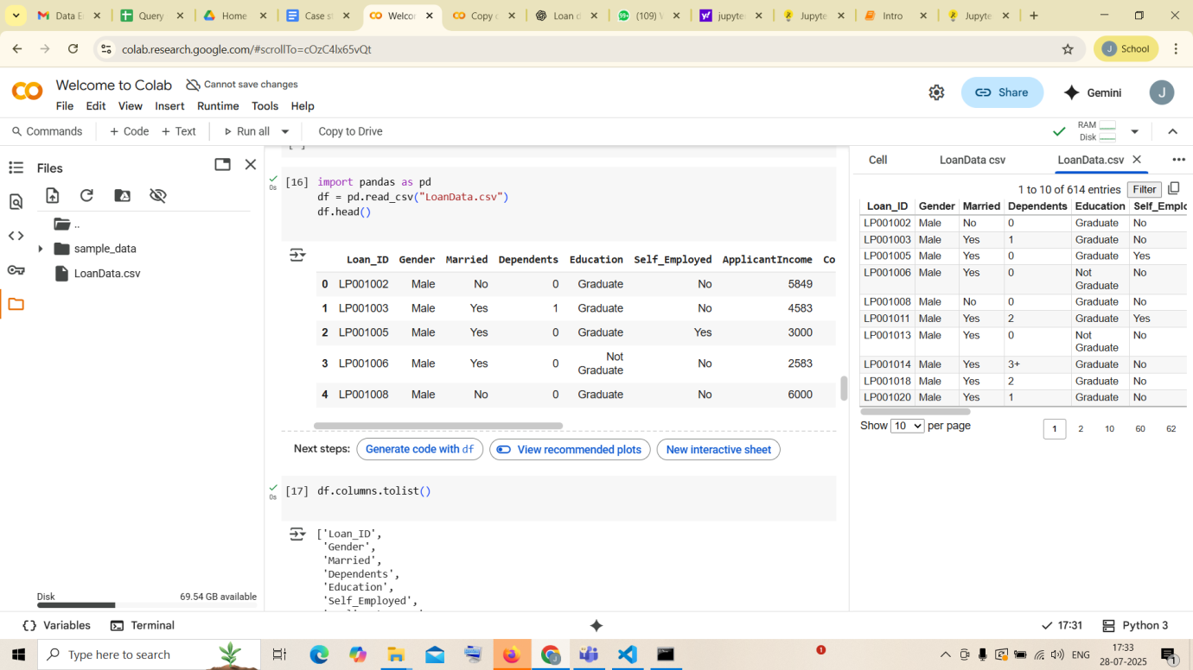

1. Printing the column names of the DataFrame

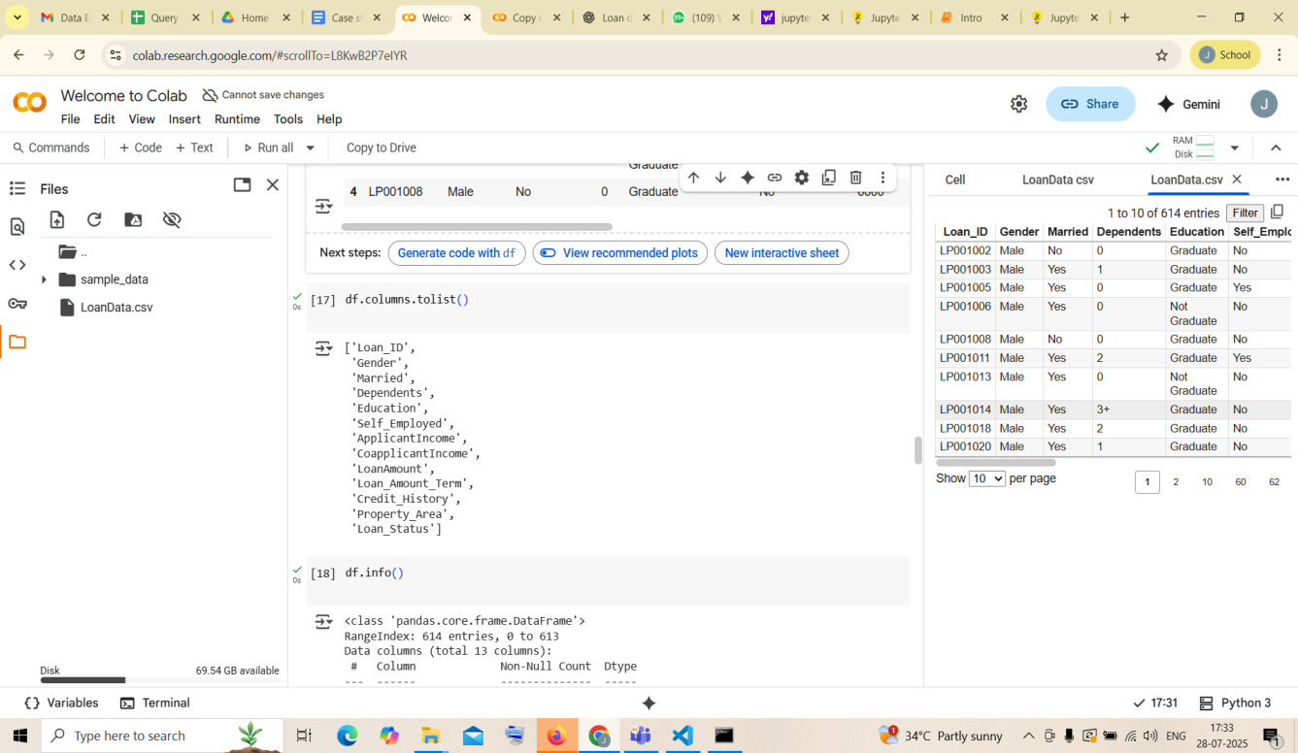

1. Summary of Data Frame

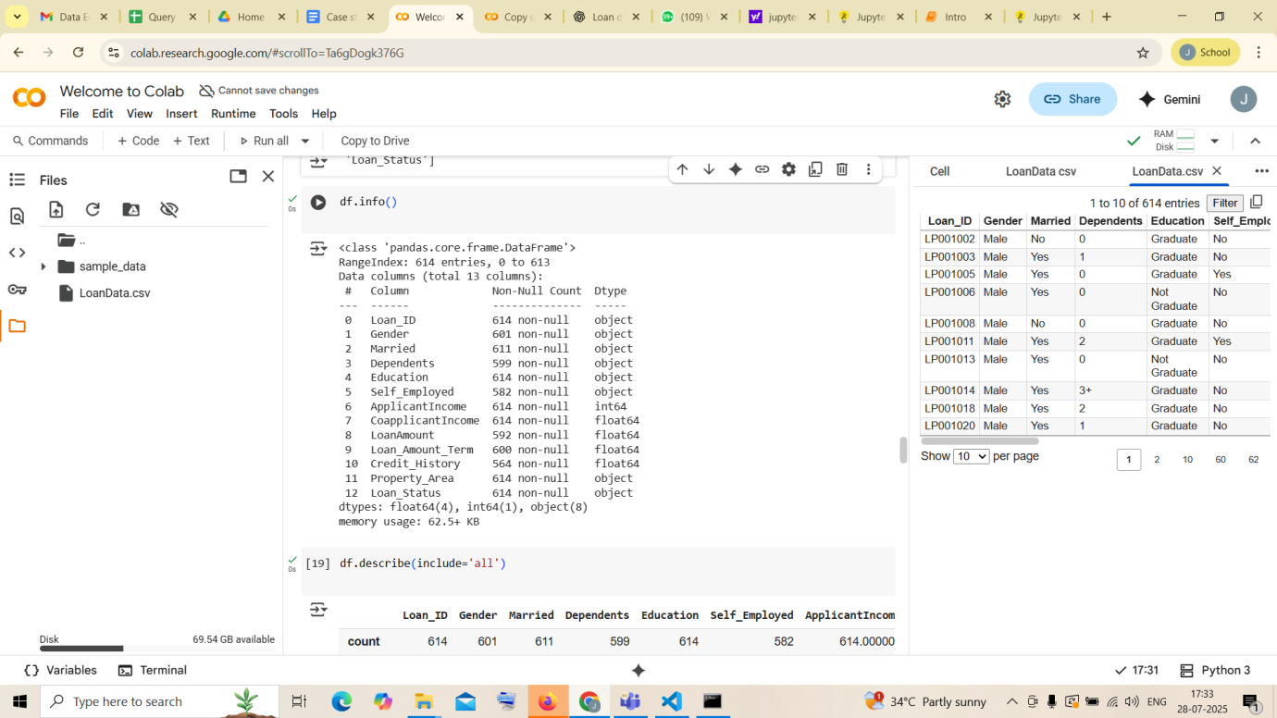

1. Descriptive Statistical Measures of a DataFrame

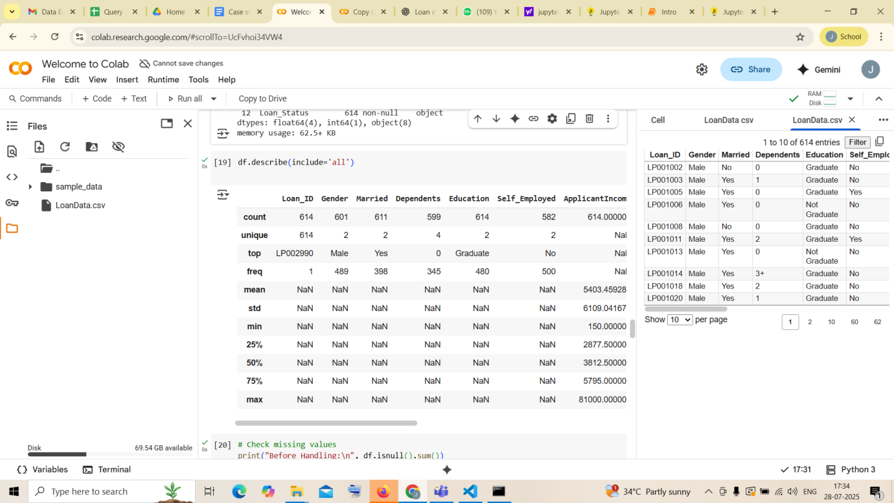

1. Missing Data Handing

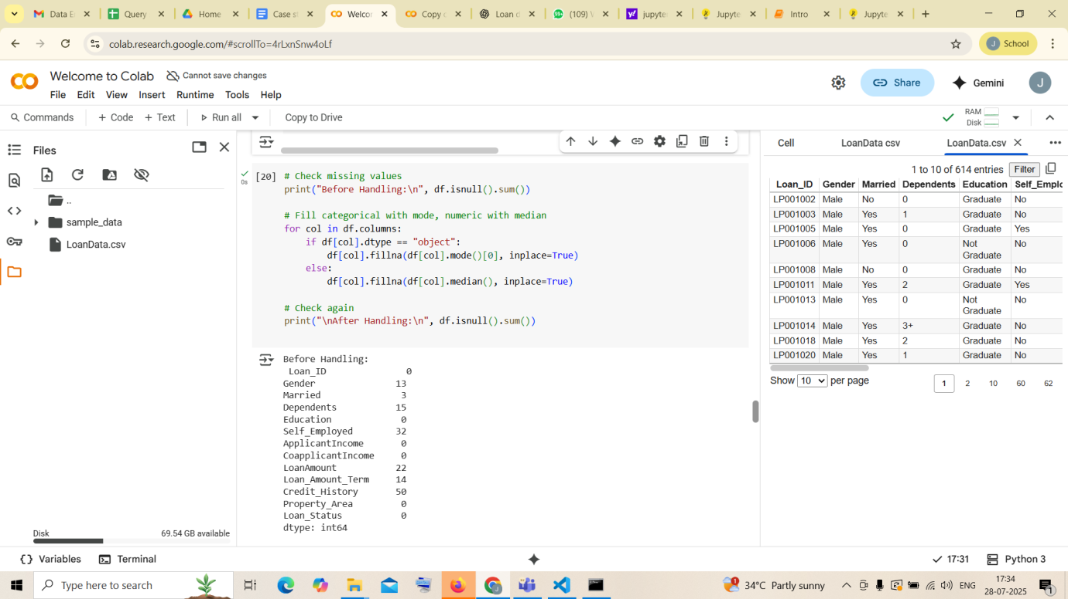

1. Sorting DataFrame values

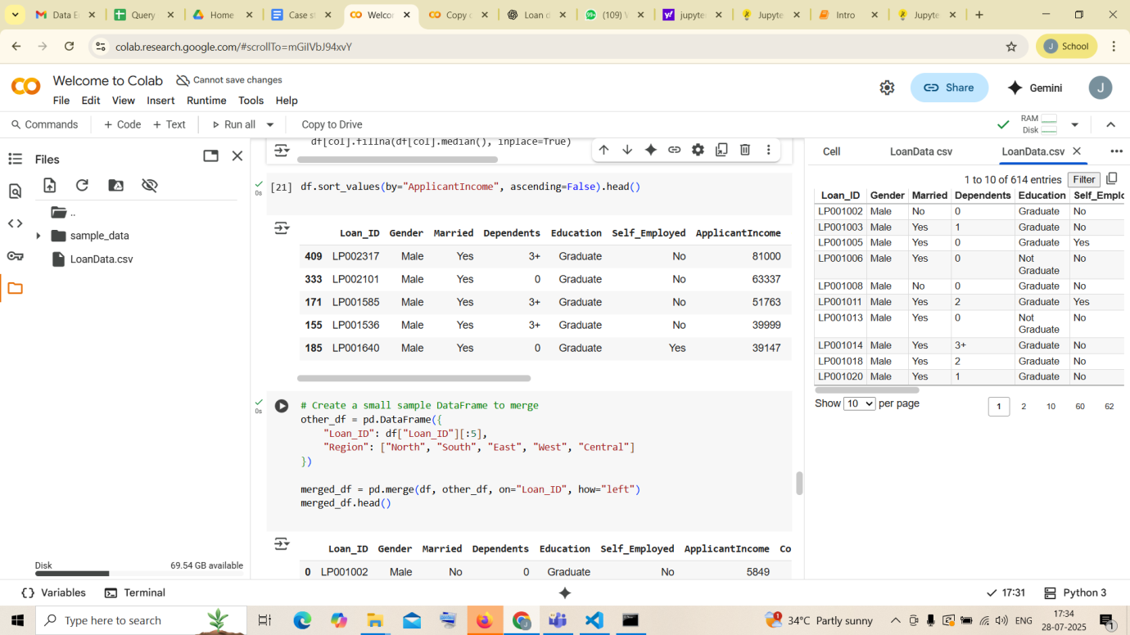

1. Merge Data Frames

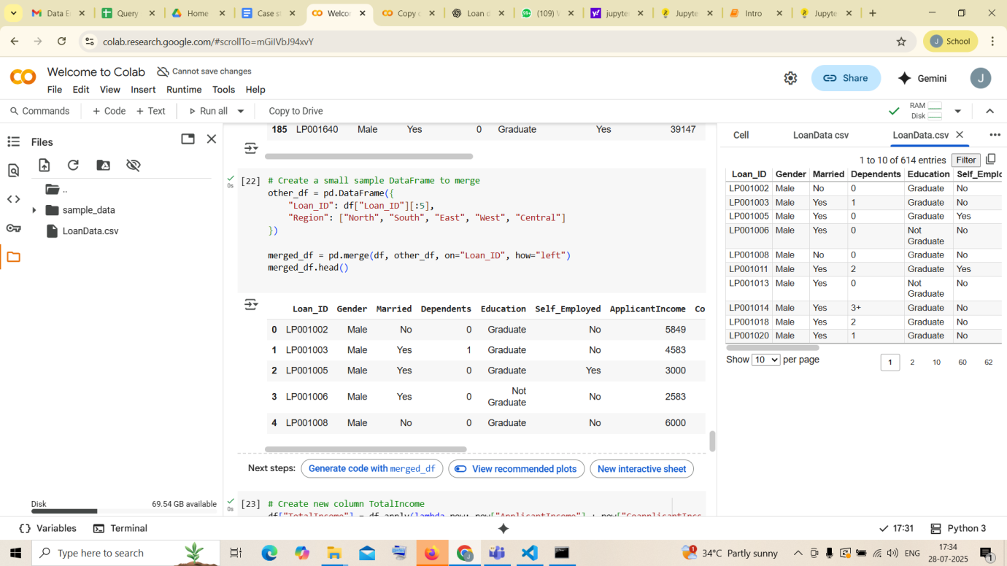

1. Apply Function

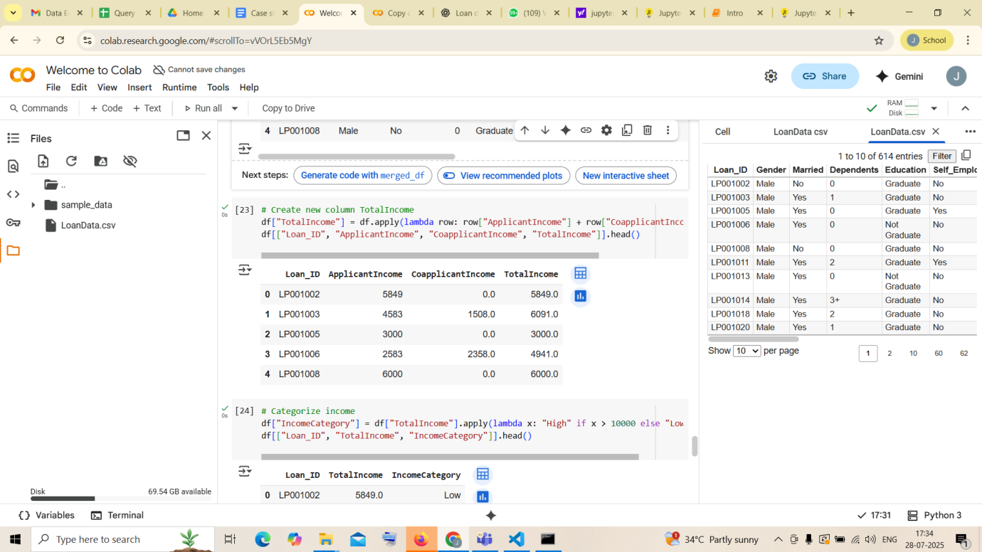

1. By using the lambda operator

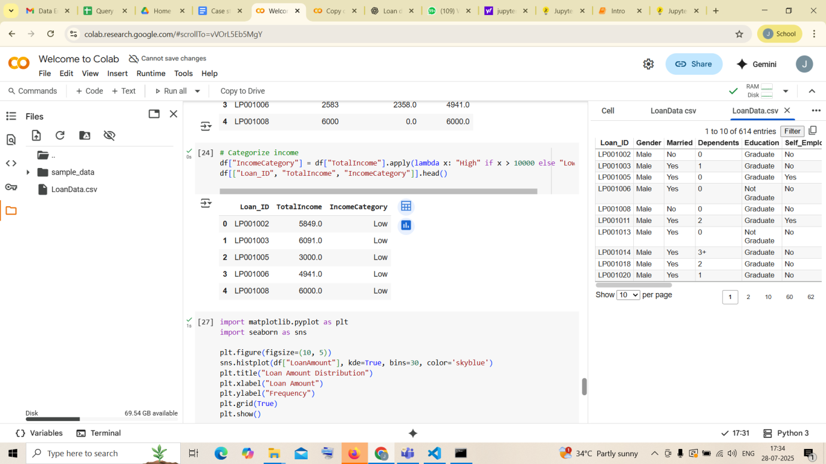

10.Visualizing DataFrame

